County of Anoka

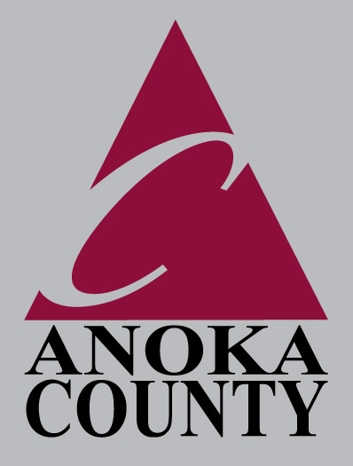

Public Services Division

*-Highway -Parks & Recreation -Surveyor -GIS -Transit -Administration*

*- Integrated Waste Management - License Bureau*

Government Center

2100 3rd Avenue STE 700 • Anoka, Mn 55303-5024

(763) 323-5700

**JON G. OLSON, P.E.**

Division Manager

Direct #763-323-5789

Fax #763-323-5682

Cell #612-850-4106

jon.olson@co.anoka.mn.us

May 22, 2013

Ms. Barb Bouljon

President

Coon Lake Improvement Association

19439 East Tri Oak Circle NE

Wyoming, MN 55092

Dear Barb:

Enclosed are three copies of the Memorandum of Understanding between Anoka County and the Coon Lake Improvement Association which provides for joint funding of Preliminary Engineering for an Outlet Diversion of County Ditch #56. This agreement was approved by the Anoka County Board of Commissioners on May 14, 2013.

Please review this agreement, sign each copy and return them (3) to my attention. Once the Memorandum is fully executed, a signed copy will be returned to you.

Please contact me if you have any questions.

Sincerely,

Jon G. Olson, P.E.

Division Manager, Public Services

JO:kr

Enclosure: Memorandum of Understanding