County of Anoka

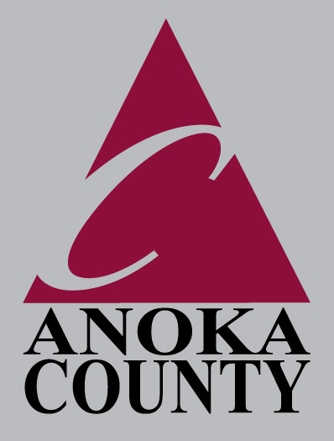

Public Services Division

*-Highway -Parks & Recreation -Surveyor -GIS -Transit -Administration*

*- Integrated Waste Management - License Bureau*

Government Center

2100 3rd Avenue STE 700 • Anoka, Mn 55303-5024

(763) 323-5700

**JON G. OLSON, P.E.**

Division Manager

Direct #763-323-5789

Fax #763-323-5682

Cell #612-850-4106

jon.olson@co.anoka.mn.us

June 6, 2013

Ms. Barb Bouljon

President

Coon Lake Improvement Association

19439 East Tri Oak Circle NE

Wyoming, MN 55092

Dear Barb:

Enclosed is one fully executed copy of the Memorandum of Understanding between Anoka County and the Coon Lake Improvement Association, providing for joint funding of Preliminary Engineering for an Outlet Diversion on County Ditch #56.

According to Section 2.B. of this agreement, Coon Lake Improvement Association is to make payment to Anoka County in the amount of $7,624.00. Please send this payment to my attention. Upon receipt, we will issue a notice to proceed to WSB and Associates.

Please contact me if you have any questions.

Sincerely,

Jon G. Olson, P.E.

Division Manager, Public Services

JO:kr

Enclosure: Memorandum of Understanding