**Highway Web Application Tools**

***Basic ID tools:***

Clicking on a construction icon on the map will produce a popup window with project information and a link to additional information.

***Search/Locate tools:***

S:\Highway\Highway\flexviewer2_5\assets\images\flagman_ahead_CUT_2.png Clicking on this tool displays a pop-up window displaying all of the construction project mid points within the county. Click on the arrow to the right of the attributes to display a link with additional info about the project. Click anywhere else within the project rectangle to zoom to the project location on the map.

You can also limit the projects shown to a particular city by clicking on the binoculars icon (Search by City), entering a city name and clicking search.

S:\Highway\DayCare\flexviewer2_5\assets\images\i_home.png Use this tool to search for an address. Enter an address in the pop-up window (Enter a house number, a street name or partial street name). If multiple matches are returned, click on the address that you are looking for and the map will zoom to that address.

Tips:

-Do not include city name or any punctuation.

-If you are having trouble locating an address, try entering just the house number, or just the street name, or even just a portion of the street name.

 It is best to use this tool when zoomed in to 1:9600 or further so that the parcel layer is visible. When you click on this tool a pop-up window is displayed with selection tools (point, line, polygon, etc). Select one of these tools and then click on the map to select parcels. The point tool allows you to select and display info for one parcel. The line and polygon tools allow you to select multiple parcels. After making a selection, panning over an individual parcel displays info for that parcel. There is also a link to the property tax website for each parcel displayed.

You can also search by entering a PIN -- click on the middle icon (Search by property ID). Clicking the results will zoom to the parcel.

***Navigation tools:***

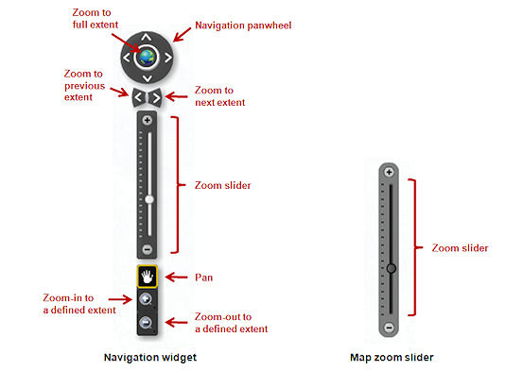

***\*\*\*\*If you have a mouse wheel, that also works for zooming in and out***

***Miscellaneous tools:***

Basemap_Aerial.jpg Flip between aerial photos and the base map

More_Button.jpg This button allows you to view a list of map layers and to turn these layers on and off.

 View street view photos (where available) and oblique aerial photos. When you click on the tool a pop-up window comes up. There are several choices you can make within the window, but selecting “Dual Viewer” and “Open in new browser window” from the dropdown lists, seem to give the best results. Once you have made your selections from the dropdowns, click on the map to view the photos of that area.

bookmarks.jpg You can use this tool to add a bookmark to the map so that you can quickly return to an area of interest on the map. To add a bookmark, click on the icon with the plus sign on it in the Bookmark pop-up window. Name the bookmark and click add. To retrieve a bookmark, click on the icon on the left in the bookmark popup window and select the bookmark you want.

Print.jpg Print a hard copy of a map.