**DWSMA Web Application Tools**

***Navigation tools:***

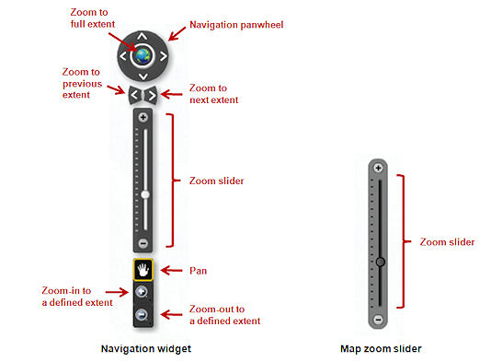

***\*\*\*\*If you have a mouse wheel, that also works for zooming in and out***

***Basic ID Tool:***

Clicking within a DWSMA boundary or on a MPCA point will produce a popup window with detailed information and a link to additional information.

***Search/Locate tools:***

 **Use this tool to view a list of all of the DWSMAs witin Anoka County**. Click on a record to zoom to the DWSMA location on the map. DWSMA Name, City, Vulnerability and a link to the Minnesota Deparment of Health’s website for that particular DWSMA are provided with this tool.

You can limit the records displayed to a particular city by clicking on the binoculars icon (Search by City), and then entering a city name and clicking the “Search” button.

S:\Highway\DayCare\flexviewer2_5\assets\images\i_home.png **Use this tool to search for an address.** Enter an address in the pop-up window (Enter a house number, a street name or partial street name). If multiple matches are returned, click on the address that you are looking for and the map will zoom to that address.

Tips:

-Do not include city name or any punctuation.

-If you are having trouble locating an address, try entering just the house number, or just the street name, or even just a portion of the street name.

***Miscellaneous tools:***

Basemap_Aerial.jpg Switch between aerial photos and the base map

Use the “Turn Layers On/Off” button to view a list of map layers that can be turned on and off – including MPCA Points, DWSMAs extending into Anoka County and House Numbers.

Print.jpg Print a hard copy of a map.