***Anoka County Elections Application***

***Help Document***

The **search tool** (shown below) can be used to search Addresses, Parcel IDs, Plats, Half Sections, Schools or Public Buildings. Use the dropdown to select the category to search.

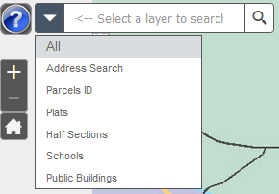

**Search tips:**

**Address Search:** Enter a house number, a street name or partial street name. If multiple matches are returned, click on the address that you are looking for and the map will zoom to that address. Do not include city name or any punctuation.

If you are having trouble locating an address, try entering just the house number, or just the street name or even just a portion of the street name.

**Property ID:** Enter with dashes – 06-31-24-33-0108

**Plat:** CIC - *CIC NO 123*

Condos - *CONDO 123*

Aud Sub - *AUD SUB NO 123*

Reg Land Survey - *RLS NO 123*

ROW Plat - *ROW NO 59 ANOKA COUNTY*

**Schools:** Enter the school name. Or enter the school type, e.g. “High School”

**Public Buildings:** Enter the type of building, e.g. “Police” or “Library”

Or enter the name of the building, e.g. “EAST BETHEL CITY HALL”

Or enter the city the building is in, e.g. “Blaine”

**Other Tools:**

 **Basemap selection** – Select between aerial photos or regular basemap

**Pictometry Tool** – Open the tool and then click on the map to display oblique aerial photos of the area on the map selected

 **Mailing Labels tool –** (See page 3)

 **Near Me tool** – Enter an address or click on the map to generate a list of geographically relevant features near the point on the map. Adjust the search radius with the slide bar on the tool

 **Layer tool** – Turn layers on or off.

 **Print tool –** The print tool will create a PDF of the area of the map that displays on the screen.

 **Legend**

 **Measure tool** – Measure area, length, or find latitude and longitude for a point on the map

 **Drawing tool –** Use to mark up a map or add annotation

 **Contact information for the Elections office**

 **Street Intersection Search Tool** – Enter the names of the streets that intersect using this format – street name”&”street name, e.g. Main”&”3rd – select the street intersection from the dropdown to zoom to the intersection

**Mailing Labels Tool**

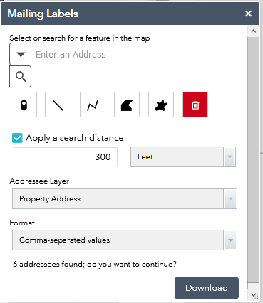

Enter an Address or Property ID

OR

Use one of the drawing tools to draw on the map to create an area of interest

Check the box to apply a search radius and add the number of feet for the size of the radius

Select from the dropdown to create either a list of property addresses or owner addresses

Select from the dropdown to choose the format – CSV file, or label-formatted PDFs

Clicking on the Download button will create a file that can be opened or saved